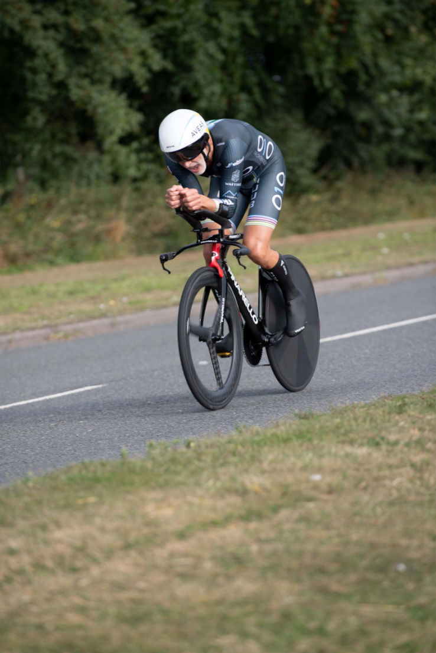

**S V T T A**

**15 Miles Speed Family Trophy**

**22nd September 2024**

**Organised by SVTTA**

Promoted for and on behalf of Cycling Time Trials  
under its Rules and Regulations

**SCOTTISH VETERANS TIME TRIALS ASSOCIATION**

***15 Miles***

***(Speed Family Trophy)***

***Promoted by Mhairi Laffoley, 22 Frankfield Place, Dalgety Bay***

**22nd September 2024 – 8.00 am start**

**Course WM.15/01**

Promoted for and on behalf of Cycling Time Trials  
under their Rules and Regulations

**Event Secretary Contact Details Timekeepers**

Mhairi Laffoley Andy Williams

22 Frankfield Place Catriona Stirling

Dalgety Bay

KY11 9LR

Email: mhairilaffoley@gmail.com

**RIDERS’ NOTES**

1. **HEADQUARTERS**

Cambusbarron Community Hall, Cambusbarron, FK7 9NU (Open from 7am)

1. **PARKING –**

Some spaces at the HQ and we have been given permission to use parking at the Bowling Clubotherwise parking is on-street (please be careful not to block drives etc). **There will be NO parking at either start or finish**

1. **REFRESHMENTS**

There will be some light refreshments at HQ.

1. **SIGNING ON AND OFF**

HQ will be open from 7am for sign on/off. Numbers will be available at HQ. It is compulsory for all riders to sign on AND sign out after completing the event. **Do not forget to sign out or you may be disqualified from the event.**

1. **Start**:

The start is on the A811 approximately ½ mile to the East of the Kersebonny Road end, Cambusbarron. It is approx. 1 ½ miles from the event HQ.

The start is accessed from Cambusbarron village by turning right from the HQ entrance, proceeding into the village, turning right down Mill Brae after about a quarter of a mile and left onto Mill Road, which leads to Kersebonny Road. Turn right at the end of the Kersebonny Road (**please take extra care as you will be turning over the course/traffic** **and riders will already be underway**) and head East towards Stirling Castle. Cross the motorway flyover and the start is approx. 320 m west of Clay Toll Roundabout.

Please DO NOT warm up on the course but note that you will need to cross through the finish line to make your way to the start. **If you are on the way to your start DO NOT adopt a racing position as you go through the finish area to avoid confusion for the timekeeper and take care not to interfere with those racing.**

1. **Map from HQ to Start**



1. **COURSE DETAILS**

The course is an out and back along the A811. From the start it heads west to turn at the Kippen roundabout. There will be Marshals at this point. They are not allowed to stop traffic so riders must adhere to highway code when negotiating the roundabout. Retrace along the A811 crossing over the motorway flyover and finish at the entrance to Falleninch Farm. On your return to the HQ please be considerate whilst riding on A811 back to Kersebonny Road as there will be other riders who have just started their race.

**Please note that the event is on an “A” class road and therefore can be busy with traffic – care should be taken at all times and the Highway Code adhered to.**

1. **SAFETY AND LOCAL REGULATIONS**

**Warming Up** - Please DO NOT warm up on the course once the event has started but note that you will need to cross through the finish line to make your way to the start. **If you are on the way to your start DO NOT adopt a racing position as you go through the finish area to avoid confusion for the timekeeper and take care not to interfere with those racing. Also on returning to HQ when you finish please make sure you do not interfere with those racing.**

Cycling Time Trials now require that all riders must wear a hard shell helmet that meets an internationally accepted safety standard. (CTT regulation 15)

Working rear and front lights, either flashing or constant, must be fitted to machines in a position visible to road users and must be active whilst the machine is in use. (CTT regulations 14(i) and 14(j))

1. **RESULTS AND PRESENTATION -** There will be a prize presentation after the event.

|  |
| --- |
| PRIZES |

**SVTTA (AAT) SVTTA Team (AAT) Tandem (AAT)**

**1st 1st 1st**

**2nd**

**3rd**

**4th**

**Fastest Male Fastest Female**

**1st 1st**

**2nd 2nd**

**1st Road Bike**

1. **START SHEET**

|  |  |  |  |  |  |  |
| --- | --- | --- | --- | --- | --- | --- |
| **No** | **Start**  **Time** | **Name** | **Club** | **Bike (TT, Road, Trike)** | **Age** | **Age Adj** |
| **1** | **8.01** | **Katherine Wren** | **Stirling Bike Club** | **TT** | **F54** |  |
| **2** | **8.02** | **Allan Duncan** | **Fullarton Wheelers** | **TT** | **61** |  |
| **3** | **8.03** | **Shirley Gibson** | **Dundee Wheelers** | **Road** | **F54** |  |
| **4** | **8.04** | **James Smith** | **Glasgow Nightingale** | **TT** | **72** | **6:00** |
| **5** | **8.05** | **Graham Jones** | **Edinburgh RC** | **TT** | **59** | **2:30** |
| **6** | **8.06** | **Andrew Wilson** | **St Christopher’s CC** | **TT** | **74** | **6:43** |
| **7** | **8.07** | **Chris Hopper** | **Glasgow United CC** | **TT** | **61** |  |
| **8** | **8.08** | **Lindsay Foster** | **Ayrodynamic Tri** | **Road** | **63** | **3:24** |
| **9** | **8.09** | **Gary Carnegie** | **Dundee Thistle** | **TT** | **52** | **1:15** |
| **10** | **8.10** | **Steve Donaldson** | **Fullarton Wheelers** | **TT** | **62** | **3:09** |
| **11** | **8.11** | **Gail Paterson** | **Newton Stewart Tri** | **TT** | **F44** |  |
| **12** | **8.12** | **Phil Wright** | **Hartlepool CC** | **TT** | **69** | **5:02** |
| **13** | **8.13** |  |  |  |  |  |
| **14** | **8.14** | **Liz Ball** | **Edinburgh RC** | **TT** | **F71** | **10:11** |
| **15** | **8.15** | **Iain Elliott** | **West Lothian Clarion** | **Road** | **50** |  |
| **16** | **8.16** | **James Robb** | **Deeside Thistle** | **TT** | **68** | **4:44** |
| **17** | **8.17** | **David Pritchard** | **Kennoway RC** | **Road** | **67** | **4.26** |
| **18** | **8.18** | **Stephen Spellacy** | **Newton Stewart Tri** | **Road** | **52** |  |
| **19** | **8.19** | **Blank** |  |  |  |  |
| **20** | **8.20** | **I Fletcher/A McLean** | **VC Glasgow South** | **Tandem** |  | **4:28** |
| **21** | **8.21** | **Alex McPhee** | **Dooleys RT** | **TT** | **62** | **3:09** |
| **22** | **8.22** | **Andrew Sim** | **Dunfermline CC** | **TT** | **56** |  |
| **23** | **8.23** | **Robert Brown** | **EH Star Cycling** | **TT** | **80** | **9:15** |
| **24** | **8.24** | **William Bunyan** | **Andrew Allan Architecture** | **TT** | **67** | **4:26** |
| **25** | **8.25** | **Fiona Davidson** | **Dundee Wheelers** | **TT** | **F56** | **4:59** |
| **26** | **8.26** | **Robert Holmes** | **Kinross CC** | **TT** | **53** |  |
| **27** | **8.27** | **Margaret McMillan** | **Deeside Thistle** | **TT** | **F60** | **5:52** |
| **28** | **8.28** |  |  |  |  |  |
| **29** | **8.29** | **Alex Munro** | **SVTTA** | **TT** | **91** | **16.10** |
| **30** | **8.30** | **Cliff Degraff** | **Velo Club Cumbria** | **TT** | **59** | **2:30** |
| **31** | **8.31** | **Steve Wallace** | **Dunfermline CC** | **TT** | **65** | **3:54** |
| **32** | **8.32** | **Steve Beecher** | **West Lothian Clarion** | **TT** | **41** |  |
| **33** | **8.33** | **Brian McGhee** | **RC Cumbernauld/ Kilsyth** | **TT** | **51** |  |
| **34** | **8.34** | **Thomas McNulty** | **SVTTA** | **TT** | **52** | **1:15** |
| **35** | **8.35** | **Iain Wilson** | **Musselburgh RCC** | **TT** | **61** |  |
| **36** | **8.36** | **John Leal** | **Deeside Thistle** | **TT** | **59** | **2:30** |
| **37** | **8.37** | **Robert Marshall** | **Andrew Allan Architecture** | **TT** | **52** | **1:15** |
| **38** | **8.38** | **Alastair Pell** | **Glasgow Nightingale** | **TT** | **61** | **2:56** |
| **39** | **8.39** | **Alan MacIntyre** | **Coatbridge Clarion** | **TT** | **51** |  |
| **40** | **8.40** | **James Muir** | **Glasgow Nightingale** | **TT** | **61** | **2:56** |
| **41** | **8.41** | **Andrew Yule** | **Deeside Thistle** | **TT** | **60** | **2:42** |
| **42** | **8.42** | **Sean Quinn** | **Law Wheelers** | **TT** | **51** | **1:06** |
| **43** | **8.43** | **Alan Davidson** | **Dundee Thistle** | **TT** | **63** | **3:24** |
| **44** | **8.44** | **Richard Tyson** | **Rock to Road CC** | **TT** | **57** | **2:06** |
| **45** | **8.45** | **James Cusick** | **Dooleys RT** | **TT** | **59** | **2:30** |
| **46** | **8.46** | **Angus Wilson** | **Dundee Thistle** | **TT** | **55** | **1:44** |
| **47** | **8.47** |  |  |  |  |  |
| **48** | **8.48** | **Marc Anderson** | **GTR Return to Life** | **TT** | **46** | **0:29** |
| **49** | **8.49** | **Sandy Waller** | **Edinburgh RC** | **TT** | **27** |  |
| **50** | **8.50** | **Rob Graham** | **GTR Return to Life** | **TT** | **32** |  |
| **51** | **8.51** | **Nico Anelli** | **Real Guts Racing** | **TT** | **26** |  |
| **52** | **8.52** | **Basil Monks** | **Edinburgh RC** | **TT** | **36** |  |
| **53** | **8.53** | **Cameron Muir** | **GTR Return to Life** | **TT** | **25** |  |
| **54** | **8.54** | **Alastair McNicol** | **Dooleys RT** | **TT** | **34** |  |
| **55** | **8.55** | **Chris Smart** | **GTR Return to Life** | **TT** | **43** | **0:12** |